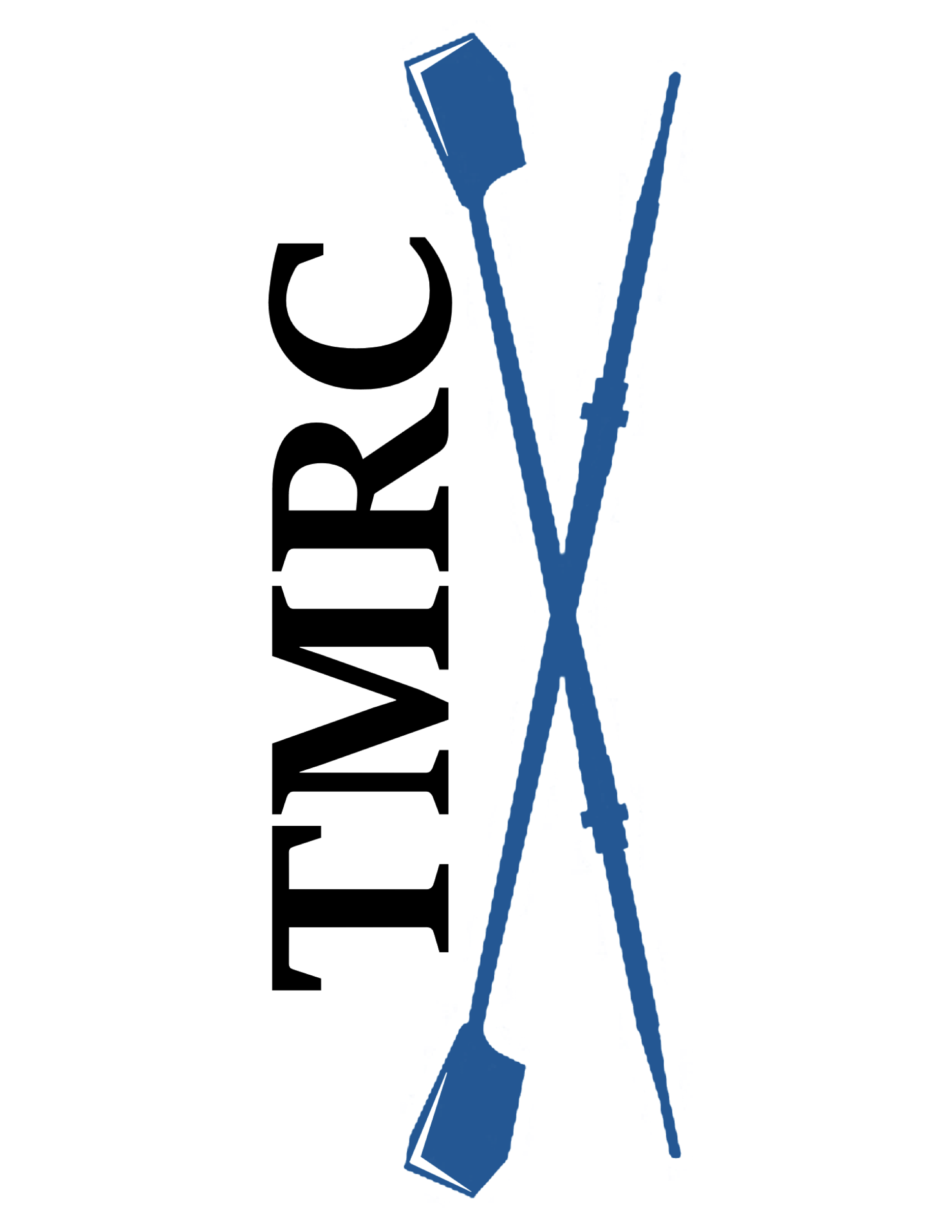
Table Mountain Rowing Club
“Learn to Row “Class Information

Are you athletic? Do you enjoy working closely with others? Do you have a love of water sports? Are you interested in participating in an amazing team sport?

Table Mountain Rowing Club is offering two “Learn to Row” sessions on Saturday, June 4, 2022. Our Club is currently a competitive and recreational Masters Club. We are hoping to develop new Novice rowers and a couple of coxswains. No previous experience is required for either position.

Schedule for June 4, 2022: Sign up for either the morning or the afternoon session.
- Morning session from 9:00 to 12:00 with sign-in from 8:30 to 8:45.
- Afternoon session from 1:00 to 4:00 with sign-in from 12:30 to 12:45.

Qualifications: Rowing is a very physical sport. You should:
- Be able to lift 35-40 lbs. above your head and also carry that weight on your shoulder.
- Be able to swim 100 yards and tread water for 10 minutes wearing athletic clothing.
- Be able to squat into a sitting position.
- Have good range of motion in your hips, knees and shoulders.
- Be at least 21 years old.

What to wear and bring: You will need to:
- Wear non-baggy exercise clothes such as leggings or spandex shorts.
- Exercise shirt/top (plan for the weather).
- Have socks to wear in the boat.
- Have tennis shoes for the indoor rowing machine.
- Bring non-metal water bottle(s) and a snack.
- Wear a hat, sunglasses and sunscreen.
- Be sure to bring your desire to work with others!

Paperwork and Homework: Once you are registered, you will need to bring the following completed items with you when you sign-in:
- Print and complete the TMRC Activities Participation form (liability waiver).
- Print and complete the Medical Consent form, in case of emergency.
- Print, complete and sign the Safety/Participation Acknowledgement form.
- Watch the US Rowing “Safety Video.” Print and complete the Safety Quiz after watching the first 28 minutes of the Safety Video.

Costs/Logistics:
- The cost for the three-hour “Learn to Row” session is $35.00. Payment must be received ahead of time to reserve your spot. Cash or check made out to “TMRC” may be mailed to: TMRC, 702 Mangrove Ave., Box 181, Chico, CA 95926. We can also accept Venmo and instructions will be provided when you register.
- The class will be held at the Forebay Aquatic Center, 930 Garden Dr., Oroville, CA.
- There is an additional charge of $10.00 for parking unless you have a pass with State Parks. Please stop at the kiosk at the entrance to purchase your pass.
- Please be prompt and have your paperwork completed so that we can conduct sign-in and begin class instruction as quickly as possible.

Class Content:
- Sign-in time with collection of completed forms and fee.
- Review of US Rowing Safety Information.
- Overview of rowing equipment and terms.
- Introduction to correct rowing form using indoor Concept 2 rowing machines.
- On-the-water instruction in a large (multi-rower) sweep boat.

Health Precautions:
- Do NOT attend if you have a temperature, are feeling ill or have any COVID symptoms.

Masters Novice Program:
So what’s next if you decide that rowing appeals to you and is something you are interested in continuing? If that’s the case, we encourage you to join our Novice group. Saturday morning sessions will be available with the purchase of a “punch card” for 5 rows for $50.00 to be used by the end of August 2022.

All rowers will be required to complete a swim test prior to becoming a TMRC team member either as a Novice or more advanced rower. Swim tests need to be completed by a WSI (Water Safety Instructor). They were available through the Oroville YMCA, 1684 Robinson Street, Oroville, CA (530-533-9622) during water fitness and open swim times for a small cost. Please be sure a WSI is available wherever you choose to take the test. Be sure to take the “Swim Test” certificate, available on our website, with you to be signed. A flip test is necessary to row in single and double boats. The Flip test will be conducted by our coaching staff.

After your punch card has been used and you desire to continue rowing with us, our Membership Fee is $150 per quarter (three months) with an additional $150 for coaching/expense fees. Our next full quarter would be October-November-December. Anyone joining prior to that would receive a prorated fee.

You also need to become a member of US Rowing. There are several membership packages available with the least expensive being $9.75 annually.

Rowing is the ultimate team sport! You must coordinate with others in your boat to achieve the best row possible! Every rower contributes!
We hope you decide to continue rowing with us.

